**Expense Management App – Functional Design Document – FLOW AUTOMATION**

**Project Overview**

**Purpose:**To automate the submission and approval of employee expenses in Salesforce.  
Employees can log their expenses, which are automatically routed to their respective managers for review and approval.

**Real-World Scenario & Problem Solved**

**Scenario**

In many organizations, employees regularly spend money on business-related activities — such as travel, client meetings, or office supplies.  
Typically, employees record these expenses in Excel sheets or emails and send them to their manager or finance team for reimbursement.

This manual process is:

* **Time-consuming** – Employees need to chase approvals.
* **Error-prone** – Managers might miss emails or approve incomplete details.
* **Lacking transparency** – No central visibility into total expenses, pending approvals, or policy violations.

**Problem Statement**

The company lacks a **centralized, automated expense management system** that ensures:

* Each employee’s expenses are properly tracked, categorized, and approved.
* Approvals are routed automatically to the correct manager.
* Data can be analyzed for budget control and compliance.

**Proposed Solution**

The **Salesforce Expense Management App** provides a streamlined, digital workflow for expense submission and approval.

**Key Benefits:**

1. **Simplified Submission** – Employees can log expenses with type, amount, and receipts in Salesforce.
2. **Automated Approval Flow** – As soon as an expense is submitted, the system routes it to the correct manager automatically.
3. **Notifications & Tracking** – Managers receive alerts and can approve or reject directly.
4. **Visibility for Finance** – Admins can generate reports by department, employee, or type to control spending.
5. **Policy Compliance** – System ensures required fields and receipts are attached before submission.

**Functionality :**

| **Feature / Functionality** | **Purpose** | **Object / Area Used** |
| --- | --- | --- |
| Custom Objects | Store Employees, Expenses, and Expense Types | Employee, Expense, Expense Type |
| Lookup Relationships | Connect Employee → Manager and Expense → Expense Type | Employee, Expense |
| Record-Triggered Flow | Automate approval process when an expense is submitted | Expense |
| Email Alert / Notification | Notify manager for approval request | Flow Action |
| Validation Rules | Ensure data integrity (e.g., Amount > 0, Receipt required) | Expense |
| Quick Actions | Approve/Reject directly from record | Expense |
| File Upload / Notes | Attach receipts and notes for each expense | Expense |
| Reports & Dashboards | Analyze total spend by type, department, or status | Analytics |
| Record Access / Sharing Rules | Control who can view and edit expenses | Security |
| Data Loader | Load master data like Expense Types | Expense Type |

**FLOW DIAGRAM**

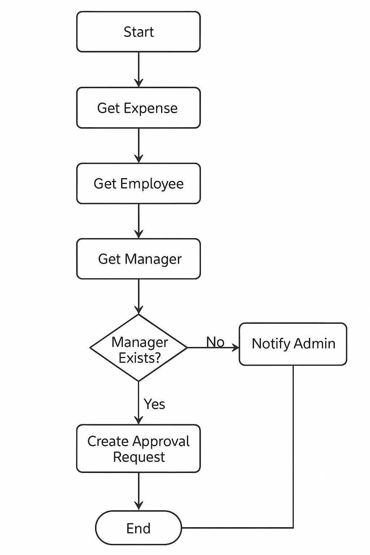

**List Of Users**

| **#** | **Role** | **Salesforce Login?** | **Typical Profile** | **Purpose** |
| --- | --- | --- | --- | --- |
| **1** | **System Administrator** | **Yes** | **System Administrator** | **Full control over all app data and setup** |
| **2** | **Manager** | **Yes** | **Standard User (or Custom “Manager” Profile)** | **Reviews and approves expenses** |
| **3** | **Employee** | **No login (represented as Employee__c record)** | **Submits expense data via Admin or Screen Flow** |  |

**Access Level :**

| **Object** | **System Administrator** | **Manager** | **Employee (Record)** |
| --- | --- | --- | --- |
| **Employee__c** | **Read / Create / Edit / Delete** | **Read (only their direct reports)** | **Not applicable** |
| **Expense__c** | **Full access** | **Read/Edit expenses submitted by their team** | **N/A (no login)** |
| **Expense_Type__c** | **Full access** | **Read** | **N/A** |
| **User** | **Read (for Manager__c lookup)** | **Read own record** | **N/A** |
| **Approval Requests** | **All** | **Approve assigned expenses** | **N/A** |

**Custom Objects**

**Employee :**

| **Field Label** | **API Name** | **Data Type** | **Description** |
| --- | --- | --- | --- |
| Employee Name | Name | Text | Name of employee |
| Employee Email | Employee_Email__c | Email | Work email |
| Manager | Manager__c | Lookup (Employee) | Links to employee’s manager |
| Department | Department__c | Picklist | IT, Finance, Sales, etc. |

**Expense :**

| **Field Label** | **API Name** | **Data Type** | **Description** |
| --- | --- | --- | --- |
| Expense Name | Name | Text | Name or short title of expense |
| Employee | Employee__c | Lookup (Employee) | Who submitted the expense |
| Expense Type | Expense_Type__c | Lookup (Expense Type) | Category of expense |
| Amount | Amount__c | Currency | Total amount spent |
| Expense Date | Expense_Date__c | Date | Date of expense |
| Status | Status__c | Picklist | Draft, Submitted, Approved, Rejected |
| Notes | Notes__c | Long Text Area | Additional details |
| Approval Manager | Approval_Manager__c | Lookup (User) | Auto-populated from Employee’s Manager |
| Receipt Attachment | Receipt__c | File (optional) | Upload proof of expense |

**Expense Type :**

| **Field Label** | **API Name** | **Data Type** | **Description** |
| --- | --- | --- | --- |
| Expense Type Name | Name | Text | E.g., Travel, Meals, Office Supplies |
| Code | Code__c | Text | Short code identifier |
| Description | Description__c | Text Area (Long) | When this expense type is used |
| Active | Active__c | Checkbox | Marks if expense type is in use |
| Default Limit (₹) | Default_Limit__c | Currency | Suggested limit per expense |
| Requires Receipt | Requires_Receipt__c | Checkbox | If proof is mandatory |
| Category | Category__c | Picklist | Travel, Office, Client, Training, etc. |

**Relationships :**

| **Object** | **Relationship** | **Type** |
| --- | --- | --- |
| Employee → Manager | Self-Lookup | One employee reports to another |
| Employee → Expense | Lookup | One employee can have many expenses |
| Expense → Expense Type | Lookup | Many expenses per type |